Ways to Prepare for School while Addressing COVID-19 Concerns
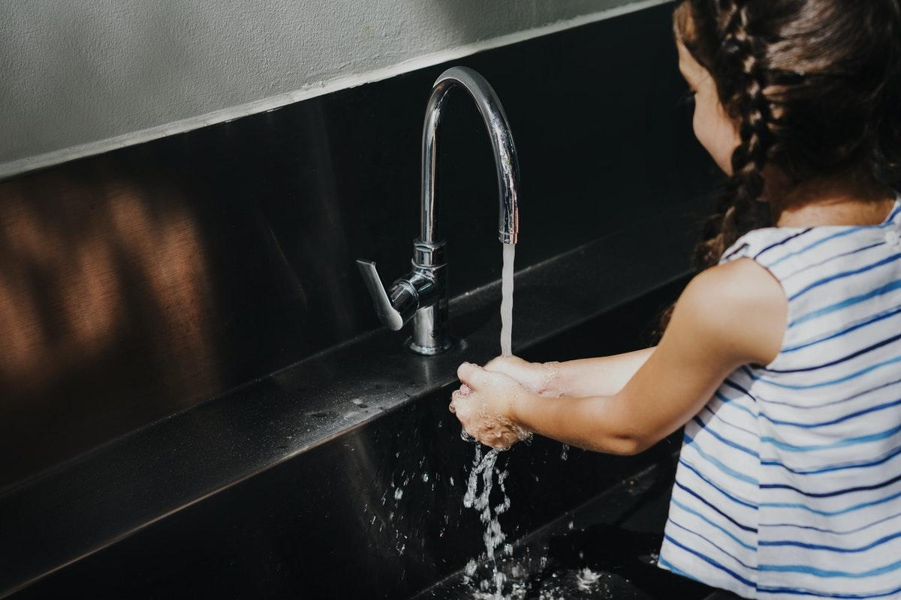
Whether through distance learning or socially distanced classrooms (or a combination of both), kids will be going back to school in no time. But for parents, these are challenging times, especially with stressed-out kids and an abundance of technology. But there are ways to prepare your kids for back to school while addressing coronavirus worries.

Beef Up Your Home’s Tech Offerings
For kids who will be learning online part- or full-time this school year, technology is essential. Make sure you’re connected and confident before the term starts.
- Know what internet speed you need—and consider upgrading.
- Sign up for online tools for educational supplementation.
- Discuss internet safety guidelines (for kids and adults).
- Address digital security before sending your kids online.

Avoid Germs All Year Long
School starting up always means a few bugs come home. This time, you need heavy-duty cleaning products to combat COVID-19.
- Teach kids proper handwashing and do it often.
- Stock up on hand soap to combat germs.
- DIY a gentler kid-safe hand sanitizer for school.
- Consider hiring a cleaning service for a safe, deep clean.

Tend to the Whole Family’s Wellness
School-age kids aren’t the only ones who benefit from regular routines and plenty of rest. Dial in the whole family so everyone feels ready for whatever the day (or school year) may bring.
- Establish a whole-family daily routine.
- Help little ones sleep better so the entire family can rest.
- Expand your family’s go-to meal list for a healthy boost.
- Spend meaningful time together each day.
Back-to-school season is always fraught with challenges. From new clothes to stocking up on supplies to making new friends, families have a lot of worries. But with these helpful tips, you can start the school year off right—despite the challenges the pandemic is causing.
Photo via Rawpixel

